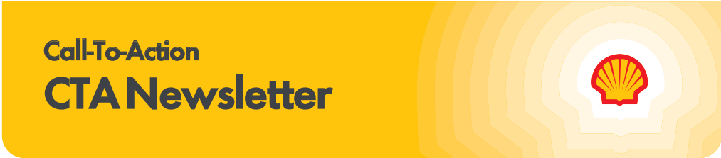

Subscribe to the CTA newsletter to receive it directly via email. Click here to find out more.
October 28, 2025
Featured Topics

Explore the Shell App Update Today!
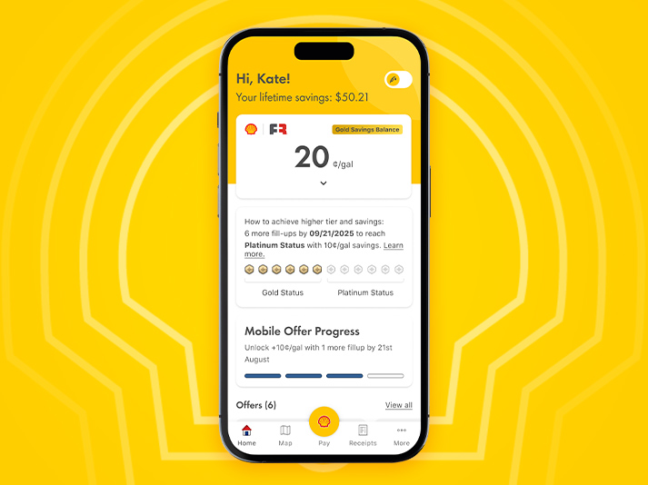
Back in April, Shell acquired the Fuel Rewards® Loyalty Program, an essential move in our digital transformation journey. Owning the Fuel Rewards® program gives Shell more control to continue to evolve and enhance the loyalty experience for our members.
In under 6 months after acquiring the Fuel Rewards® program, we’ve reached a major milestone in Shell’s digital journey: the initial phase of integrating Fuel Rewards® directly into the Shell App. This initial release creates a more seamless, rewarding experience for our customers.
What’s New in the Shell App Today:
- Automatic Fuel Rewards® Enrollment: New users are instantly enrolled—no extra steps required.
- Refreshed Home Screen: Quick access to rewards, tier status, and progress tracking.
- Tier Status Tracking: See your Fuel Rewards® tier and benefits at a glance.
- Map-Based Offers: Discover personalized and national in-store Fuel Rewards® offers.
- All Transaction Receipts: View all loyalty transactions in one place.
- Live Chat Support: Get help in real time, right from the app.

This release lays the foundation for our fully unified Shell App experience, coming in Q2 2026, where all Fuel Rewards® features will be available in the Shell App. The one-app experience will enhance the member journey by offering greater convenience across features—making it easier to engage with rewards, offers, and account tools all in one place.

Download the Shell App or update to the latest version (8.10) to start exploring!
Stay connected via the Shell MarketHub for ongoing updates.

The Giving Pump 2025: Wrap-Up & Donation Submission

The 2025 Giving Pump campaign officially closed on October 31! To help you celebrate and share your impact, we’ve refreshed the Marketing Toolkits on the Force for Good MarketHub page with customizable “wrap-up” assets:
- Social Media & Press Release Templates
- Window Banners & Donation Check Templates
These can be personalized with your donation total and charity name and printed locally to display at your site or use in photos and presentations—an easy way to thank customers and highlight your community support.
Charity Toolkit Reminder
The Charity Marketing Toolkit has also been updated. Please share the link with your charity partners so they can promote the campaign’s success through their own channels—another great way to engage the community and celebrate the impact you’ve made together.
Donation Submission
You’ll receive an email in early November with instructions to submit your donation total. Please submit by December 1.
- Need pump volume data? It will be available the week of November 10 via your Territory Manager or by emailing SOPUS-The-Giving-Pump@shell.com.
- Reminder: Wholesalers are responsible for making donations directly to their selected charities, unless enrolled in the Turnkey St. Jude option.

Shell | Fuel Rewards® Credit Card POP Kits Ship This Week!
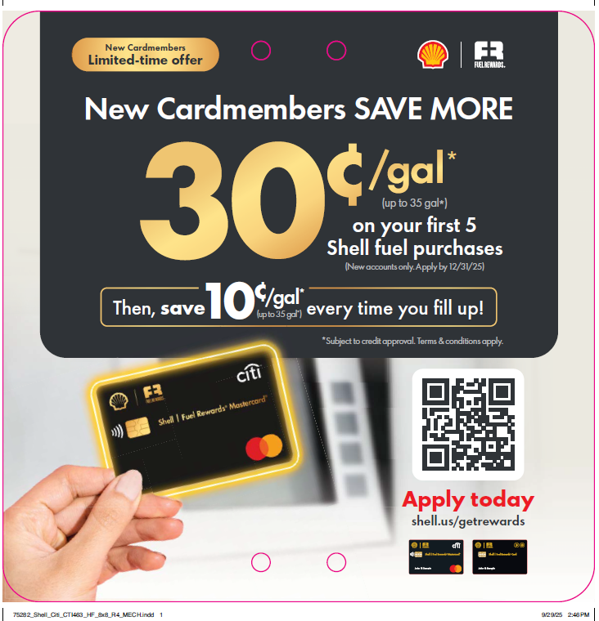
The Shell | Fuel Rewards® Credit Card combines payment cards and loyalty into one convenient transaction. Our Shell | Fuel Rewards® cardholders transact 3X MORE* than the average Fuel Rewards® consumer, and 6X MORE* than non-loyalty credit card holders!
To highlight the card and benefits, new POP for select assets are shipping out this week to be displayed at sites by November 3rd. To help prepare for the shipments here are a few actions you can take to make the most of the onsite consumer communications:
- Ensure all site staff review the planogram that is included in the POP shipments which list specific display instructions.
- Post the Shell | Fuel Rewards® Credit Card POP materials as soon as you receive them, or by November 3rd.
Your store profile and exemption status determine the materials you will receive. If you do not receive certain POP materials, you may need to update your store profile or exemption status. Please visit the Advertising Page on MarketHub to view a digital copy of the planogram.

*When comparing average SHELL | FUEL REWARDS® cardholder transaction counts to average Fuel Rewards® customer transaction counts and average SHELL | FUEL REWARDS® cardholder transaction to non-loyalty credit card user transactions over a 6-month period.
PMTDR Announcements
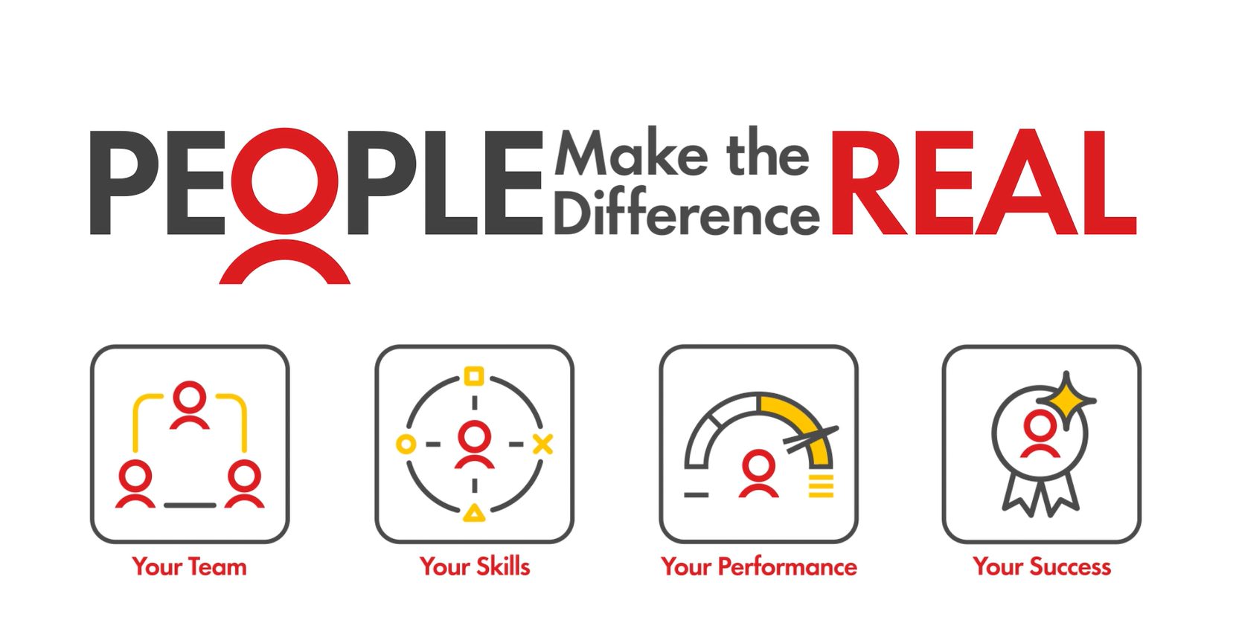

2025 Frontline Hero Nominations are now open!
PMTDR Frontline Heroes provides wholesalers an opportunity to spotlight your exceptional Store Managers, Assistant Store Managers, or Dealers who consistently go above and beyond - driving results, inspiring their teams, and delivering outstanding customer experiences. Finalists receive meaningful recognition through impactful rewards, like PMTDR trips and generous cash prizes! More than just a thank you, PMTDR recognition is a strategic tool to energize and elevate frontline performance.

There are 3 nomination categories:
- Frontline Hero of the Year – Recognizes exceptional team leadership in driving results and delivering outstanding customer service
- Convenience Retail Manager of the Year – Honors leadership excellence in driving inside (non-fuels) sales results
- Fuels Hero of the Year – Celebrates leadership in achieving/exceeding fuel targets and increasing loyalty penetration

There are 3 levels of awards:
- Local Trip for US Finalists: 1 finalist from each nomination category + their guest are invited to the PMTDR Local trip at The Broadmoor in Colorado Springs, March 30 – April 2, 2026
- Global Trip for Americas Region Finalist + $5,000: US Finalists go into a pool with other Americas (Canada & Mexico) finalists, and an Americas Regional Winner is selected for each category. Americas Regional winners + guest are invited to the Smiling Stars Dubai trip May 19-22, 2026 and receive $5,000.
- $5,000 Global Champion award: Americas Regional winners attending the Smiling Stars Dubai trip are pooled with the other regional winners in each category and 1 winner per category is named as Global Champion. Global Champions receive $5,000.

All nominations should include metrics and specific examples of what the nominee has done to be nominated. Click here for the nomination template.

Congratulations to the PMTDR Period 2 Top 10%!
Period 2 results are in! Congratulations to the sites that placed in the top 10% of their region by delivering the best in customer service (MMP), Loyalty penetration and Fuel volume growth! Wholesalers will receive $150 in Visa Gift cards to deliver to their winning teams.
Rank results can be found by region, by clicking here.

Reminder: PMTDR 2026 Program Change
As announced earlier in the year, the 2026 PMTDR program will change from calendar year rank to rolling-12 months.
The 2026 scorecard will use:
- MMP Shops: Period 3 2025, Period 1 2026 and Period 2 2026
- Loyalty and Fuel Volume: October 2025 – September 2026

2026 end of year results will be delivered in November allowing wholesalers more time to identify, announce, and celebrate winners.

It’s important to note: MMP Period 3 scores & Loyalty and Fuel volumes October – December 2025 will be used for both the 2026 and 2027 trip calculation.
Important Updates

Holiday Shell Gift Card Shipments Coming Soon!
The Holidays are almost upon us! Your Shell Gift Card holiday shipments begin in late November.

What to Expect:
- NO changes to how stores activate or redeem
- New plastic cards can be added to the Shell App!
- AND customers can now add MULTIPLE gift cards to their Shell eGift Card balance, up to $250! This improves app user experience when paying with Shell eGift Cards.

Card Shipments:
- Estimated for last week in November, but delivery times may vary based on carrier.
- Shipments will include instructions on how to dispose of legacy cards or how to contact RPG for additional orders or questions related to the change.
- All legacy card inventory (example below) should be removed from POS display units and disposed of per previous communications and instructions included on flyer in shipments.
- No changes to current display signage. Signage will be updated later this year.

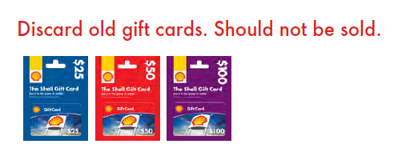

Q4 AMEX Card-Link Offer in Market
Shell and AMEX have launched a limited-time card-linked offer to re-engage lapsed AMEX card holders.

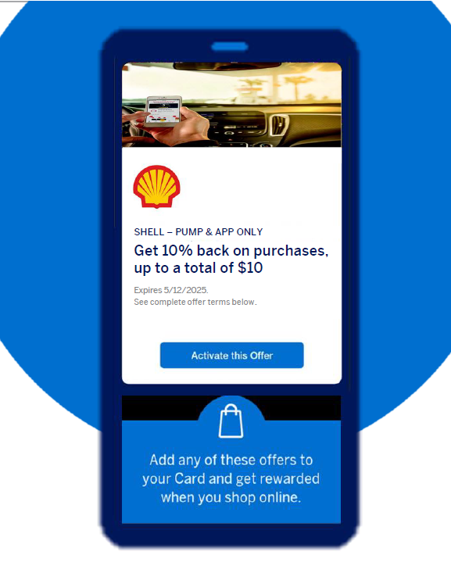
How They Earn
Targeting AMEX Card members with no spend at Shell within prior 6 months, this offer will be available from AMEX via: AmericanExpress.com, AMEX Mobile App, Dynamic Email to AMEX consumers. Consumer selects offer to ‘Activate’ and will receive 10% back on all purchases at Shell up to a total of $10. The consumer then receives a statement credit on their monthly AMEX invoice. This offer will last from October 14, 2025 to December 31, 2025. AMEX will be tracking long-term spending from re-engaged cardholders for 90 days post-campaign to gauge stickiness.
Commercial Benefits
The Q4 AMEX Card-Link offer will leverage the nationwide AMEX audience with estimated redemption rates of 10-20% of consumer opt-ins. Driving inactive consumers back to Shell, this offer will encourage more foot traffic and lead to more C-store sales and fuel. This campaign is fully funded by Shell & AMEX.
New “Schedule a Call” Feature Now Available!
We’re making it easier than ever to connect with the Shell Solutions Center. Our new Schedule a Call tool lets you book time with the Shell Solutions Center at your convenience—no waiting in queues, and you can invite others from your team to join the discussion if needed. When scheduling, you’ll be asked to provide your contact details, topic or question, and any relevant account or location information so our team can prepare and support you effectively. A recap email will be sent after the call as well.



A New Diamond Deal with T-Mobile Business Internet


Shell & T-Mobile have teamed up to bring America’s Largest 5G Network to Shell Retailer locations nationwide. This exclusive Diamond Deal offer includes:
- Enterprise-Grade 5G Internet for $110/month*
- Professional installation with premium hardware
- 24/7 support via Shell Help Desk + T-Mobile Tier 2
- Strategic site selection ensures optimal service
Be on the lookout for your 2025 Diamond Deal brochure in the mail next month. Scan the QR code on the flyer or visit the Shell T-Mobile Microsite hyperlinked on the image to request a Network Location Assessment from a T-Mobile for Business Expert. See if your sites qualify for primary or backup 5G service.
*Rooftop installs require upgraded hardware and an additional $30/month
The Power of Loyalty

In-Store Rewards – November Offers
Help drive consumer awareness and increase your c-store sales by printing the POP and displaying the In-Store Rewards products near the register. As a reminder, members with Platinum Status earn 2x on all In-Store Rewards offers.
- Power Deal - Buy 3 WELCH'S® Juicefuls®, earn 10¢/gal
- Buy 2 100% Natural Spring Water 20 oz, earn 5¢/gal
- Buy 2 Mix & Match Sparkling Ice Caffeine, Starburst, and/or Popwell, earn 5¢/gal
- Buy 2 Saratoga® 16oz/28oz, earn 5¢/gal
- Buy 2 Reese's/Hershey's/KitKat Std, earn 5¢/gal
- Buy 2 Kettle or Cape Cod Chips 1.7oz-2oz, earn 3¢/gal

Click here (please link to MarketHub or Fuel Zone) to view the reference materials including high resolution artwork, POP templates for local printing, flyer with UPCs, change mat inserts and Wayne Anthem dispenser slides. Check the Fuel Rewards® or Shell App regularly to view additional short-term digital only offers.
If you have any questions, please contact mark.dyer@shell.com.

T-Mobile Tuesday Enhanced Offer
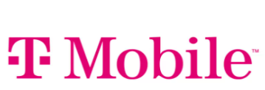
T-Mobile customers that claim the T-Mobile Tuesday offer will receive an enhanced offer of 20¢/gal. The 20¢/gal enhanced offer includes Gold Status and is limited to 20 gallons. This limited-time offer will run on Tuesdays from October 28 through December 23.

10¢/20¢/30¢ Acquisition Offer Change Mat Insert
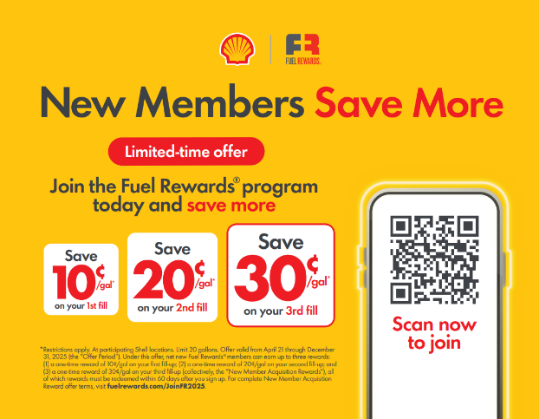
With the extension of the 10¢/20¢/30¢ acquisition offer through December 31, 2025, we received several requests to update the change mat insert so site staff can keep the momentum going with promoting the offer to sign up new Fuel Rewards® members. We are happy to share that the updated print-ready change mat insert is available for you download here in MarketHub to take to a local printer.

