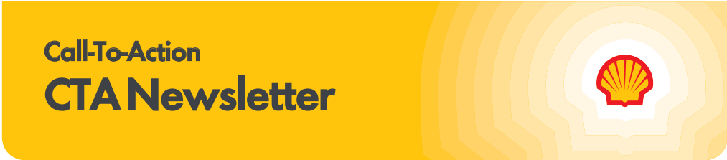

Subscribe to the CTA newsletter to receive it directly via email. Click here to find out more.
November 18, 2025
Featured Topics

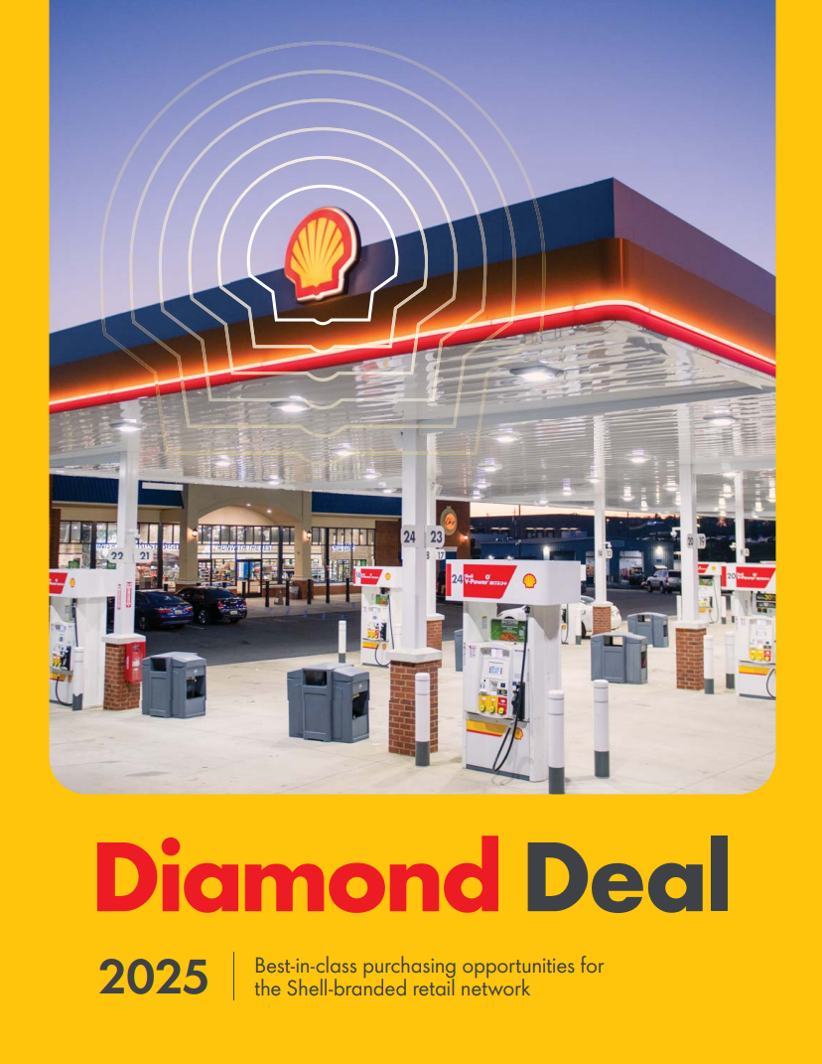
New Diamond Deal Booklet Available

Take advantage of Shell’s national scale and strategic supplier relationships to save on purchasing deals designed to enhance your retail sites. There are no fees to participate and wholesalers can extend the offers to their dealers.

The new 2025 Diamond Deal Booklet arrives at wholesalers’ offices in early December! The booklet includes Shell’s latest purchasing deals for a wide range of image, technology, and business solutions. Expect five physical copies for your office, followed by a digital, interactive version that will be available on Shell MarketHub and Motiva Fuel Zone in December.

NEW & limited-time Diamond Deals to consider:
- PDI Firewall as a service - 3 months free offer ends December 31, 2025
- Invenco by GVR FlexPay 6 OPT - trade-up offer ends

December 31, 2025
- Mashgin smarter, faster checkout solutions
- T-Mobile for Business 5G internet service
- XPEL protective film for dispenser screens and surfaces
- Cintas restroom cleaning solutions

If you have questions or feedback about Diamond Deal program, contact Meg Love.

10-20-30 Fuel Rewards® New Member Offer Extension & New POP

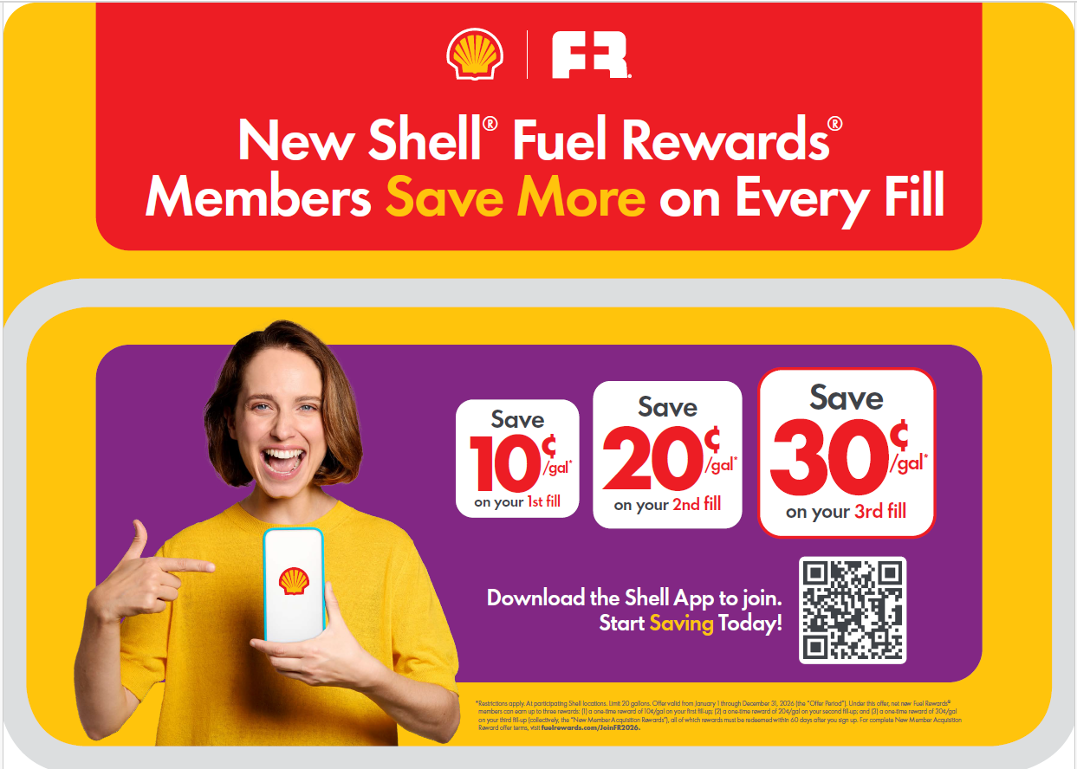
We’ll be kicking of 2026 by extending our 10-20-30 Fuel Rewards® New Member Offer to keep customers coming back and boosting your bottom line. New Point-of-Purchase (POP) materials hit the market January 5th, designed to make joining easy and rewarding.

Key Dates:
- Dec 19: Kits ship—set the stage for success.
- Jan 5: Launch Day—make rewards the first resolution customers keep!

How Customers Join:
NEW: Customers simply scan the QR code on POP materials to join Shell® Fuel Rewards® in the Shell App. With one-step integrated account creation, every new Shell App user becomes a Fuel Rewards® member - fast, seamless, and ready for savings all year long.

Why It Matters:
More active members = more gallons + more in-store sales. Every active member delivers 360 gallons + $115 in-store spend annually*.

New MMP Portal Coming in January
To provide a more seamless and user-friendly experience for wholesalers, Shell is launching a new Mystery Motorist Program (MMP) Portal in January 2026! The new portal will provide all of the same program features that exist today, but with upgrades and new features along the way.

Beginning for Period 1 (P1) 2026, all MMP shop results will move to the new portal accessible via MarketHub. To help guide you through this transition, the following resources are available:

- Webcast Recording for Portal Walkthrough from the November 10 Shell Mobility Academy session: View on the Shell Mobility Academy MarketHub Page
- New Portal Resource Pack: Access from the MMP Page on MarketHub

Stay tuned for more communications, including a calendar invitation to the December 9 Shell Mobility Academy webcast where we will share more information about the portal as well as best practices.
Important Updates

December Shell Mobility Academy Webinar
Join us on December 9 at 11am CT for a Shell Mobility Academy webinar to learn more about the New MMP Portal Best Practices, 2026 MMP Program Changes & Other Programs Reminders.

During the call, we will cover tips and best practices related to the upcoming MMP Portal launch in January as well as co-op reminders to ensure you don’t miss out on using your funds.

We will also cover PMTDR end of the year updates and review important 2026 program dates.

Holiday Shell Gift Card Shipments Coming Soon!
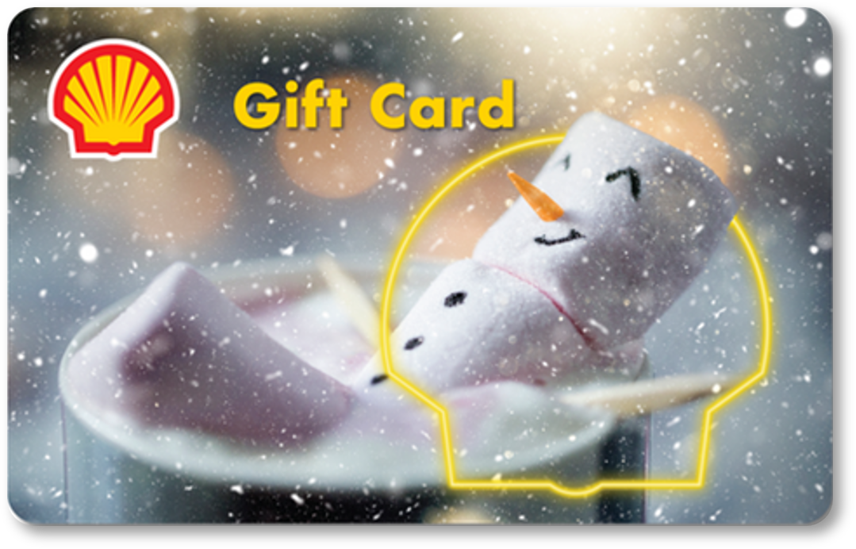
The Holidays are almost upon us! Your Holiday Shell Gift Cards will start shipping the week of November 17th.
What to Expect:
- NO changes to how stores activate or redeem.
- New plastic cards can be added to the Shell App!
- AND customers can now add MULTIPLE gift cards to their Shell eGift Card balance, up to $250! This improves app user experience when paying with Shell eGift Cards.
Card Shipments:
Estimated for last week in November, delivery times may vary based on carrier. Shipments will include instructions on how to dispose of legacy cards or how to contact RPG for additional orders or questions related to the change.

All legacy card inventory should be removed from POS display units and disposed of per previous communications and instructions included on flyer in shipments. There are no changes to current display signage. Signage will be updated later this year.

Free Network Location Assessment with Your Diamond Deal 5G Business Internet

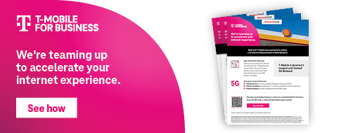
When you sign up on the microsite for this exclusive Diamond Deal 5G Business Internet with T-Mobile, you’ll receive a Network Location Assessment report for free. This detailed analysis uses Shell and T-Mobile data to confirm coverage at your exact site, ensuring the best connectivity experience.

Work directly with a T-Mobile for Business Expert through our microsite and unlock the full value of the Diamond Deal including:
- Enterprise-Grade 5G Internet for $110/month*
- Professional installation with premium hardware
- 24/7 support via Shell Help Desk + T-Mobile Tier 2
- Strategic site selection ensures optimal service

Scan the QR code on the T-Mobile Diamond Deal flyer or visit the Shell T-Mobile Microsite hyperlinked on the image above to request a Network Location Assessment from a T-Mobile for Business Expert. See if your sites qualify for primary or backup 5G service.

*Rooftop installs require upgraded hardware and an additional $30/month

The Power of Loyalty

In-Store Rewards – December Offers
Help drive consumer awareness and increase your c-store sales by printing the POP and displaying the In-Store Rewards products near the register. As a reminder, members with Platinum Status earn 2x on all In-Store Rewards offers.
- Power Deal - Buy 3 WELCH'S® Juicefuls®, earn 10¢/gal
- Buy 2 100% Natural Spring Water 700 mL, earn 5¢/gal
- Buy 2 Mix & Match Sparkling Ice Caffeine, Starburst, and/or Popwell, earn 5¢/gal
- Buy 2 Saratoga® 16oz/28oz, earn 5¢/gal
- Buy 2 Red Vines, earn 5¢/gal
- Buy 2 Chapstick, earn 5¢/gal
Click Here to view the reference materials including high resolution artwork, POP templates for local printing, flyer with UPCs, change mat inserts and Wayne Anthem dispenser slides. Check the Fuel Rewards® or Shell App regularly to view additional short-term digital only offers.
If you have any questions, please contact mark.dyer@shell.com.

New Loyalty Partner Sonesta Hotels
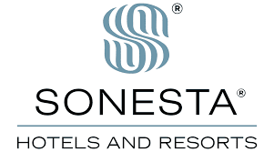
Sonesta Travel Pass members can unlock saving with Shell Fuel Rewards®

Limited Time Offer: Enroll by December 31, 2025 to save more each time you fill up.
10¢/gal off your 1st fill
20¢/gal off your 2nd fill
30¢/gal off your 3rd fill

PLUS: Enjoy complimentary gold status with 5¢/gal every fill through the end of 2026.
Subject to Sonesta Travel Pass and Fuel Rewards® terms and conditions.

