

Subscribe to the CTA newsletter to receive it directly via email. Click here to find out more.
December 16, 2025
Featured Topics

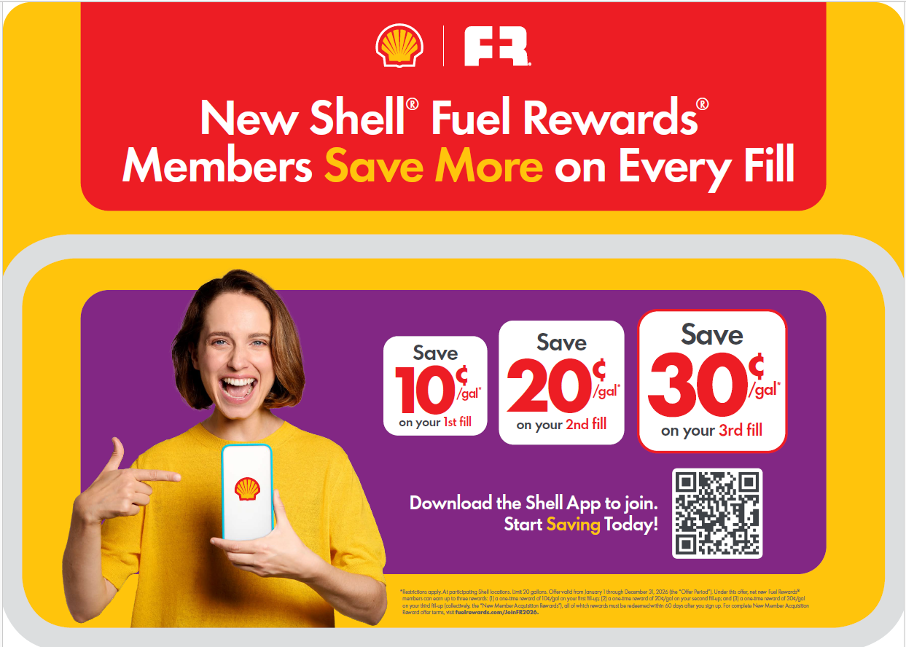
10-20-30 Shell® Fuel Rewards® New Member Offer – Reminders and POP Links

As announced in November, we are extending our 10-20-30 Shell® Fuel Rewards® New Member Offer through December 31st, 2026, to keep customers coming back and boosting your bottom line! New Point-of-Purchase (POP) materials hit the market January 5th, designed to make joining easy and rewarding.

Links to Learn More:
- Current Campaigns MarketHub Page – View POP materials, including the planogram
- Fuel Rewards® MarketHub Page – View more information about the upcoming campaign

Key Dates:
- Dec 19: Kits ship—set the stage for success.
- Jan 5: Launch Day—make rewards the first resolution customers keep!

How Customers Join:
Customers simply scan the QR code on POP materials to join Shell® Fuel Rewards® in the Shell App. With one-step integrated account creation, every new Shell App user becomes a Fuel Rewards® member - fast, seamless, and ready for savings all year long.

Why It Matters:
More active members = more gallons + more in-store sales. Every active member delivers 360 gallons + $115 in-store spend annually*.

*Average annual purchases by Fuel Rewards Members.

January Shell Mobility Academy Webinar
Join us on January 13 at 11am CT for a Shell Mobility Academy webinar to learn more about leveraging MarketHub 2.0 for your business.

During the call, we will cover MarketHub subscriptions, the contact manager tool, and reminders about the new Mystery Motorist Program changes.

The invitation for January and past recordings can be found here.

Network Transformation Urgent Actions
As you know, MarketHub 2.0 has arrived! Thanks for all the engagement and feedback so far.
This is a reminder that MarketHub 1.0 API will be decommissioned on December 20 and MarketHub 1.0 platform will be fully retired on December 22.
Please take these immediate actions to ensure you have successfully transitioned to MarketHub 2.0:
- Log in to MarketHub 2.0 TODAY
- If you have not yet activated your MarketHub 2.0 account, look for an activation email from noreply.ShellMarketHub@shell.com containing your unique log in link. The link in that email is only valid for 7 days, after which you will need to select the ‘Forgot password' link on the login page to access the platform.
- It is critical that at least (1) Super User from your organization is logged in by December 22. Super Users manage permissions and approvals related to your sold to account.
- Confirm API connection to MarketHub 2.0
- If you have not yet contacted your Service Provider, please provide them with Service Provider instructions found in MarketHub 1. 0 Network Transformation MarketHub page or MarketHub 2.0 Additional Resources page
- Contact SSC to confirm that your API connection to MarketHub 2.0 is successful, in order to ensure continued automatic delivery of documents into your back-office systems
Contact SSC via email at [SSC@Shell.com] or click this link to schedule a call with the SSC for step-by-step assistance with any of the above actions.

Product Codes Important Action
A number of locations are reporting incorrect product codes (including Regular and Premium grades that are switched), which is impacting the accuracy of volume calculations. Please request that a member of your team or your local technician review the product codes configured at your location to ensure they align with the latest Shell standards, which are found in MarketHub 2.0 Additional Resources page. You may also hear from us directly if we identify possible error(s) that require correction.
If you would like 1:1 assistance with updating your product codes, click here to Schedule a Call with a Technology Expert.
Important Updates

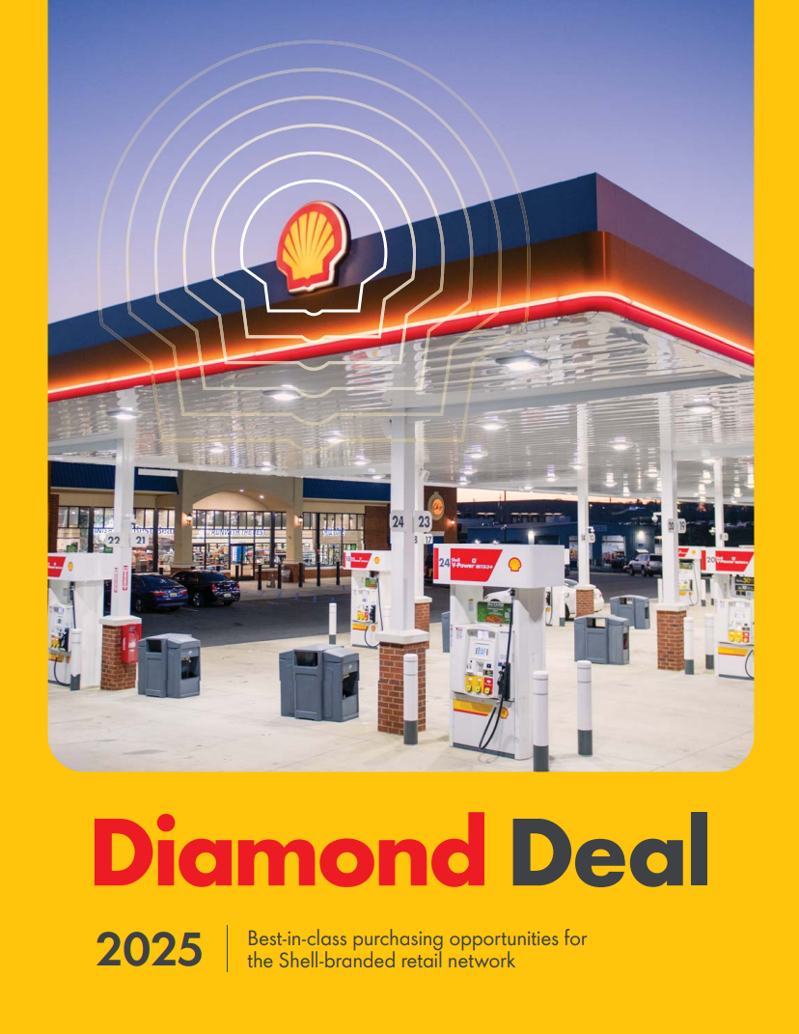
New Diamond Deal Booklet Reminder

Wholesalers should have complimentary copies of the new 2025 Diamond Deal Booklet that were shipped out last month! This booklet includes Shell’s latest purchasing deals for a wide range of image, technology, and business solutions. The digital, interactive version will be available on Shell MarketHub on December 21. We encourage you to share these deals with your dealers.

If you have questions or feedback about the Diamond Deal booklet or program, contact Meg Love.

Shell + T-Mobile Diamond Deal: 5G Internet + Pro Install


Upgrade your connectivity with the Shell T-Mobile Diamond Deal 5G Business Internet—starting at just $110/month*. This exclusive offer delivers enterprise-grade 5G, premium hardware, and professional installation for guaranteed day-one reliability. Certified installers ensure optimal router placement, whether indoor or rooftop for peak performance and seamless operations.

Visit the Shell T-Mobile Microsite hyperlinked on the image to request a Network Location Assessment from a T-Mobile for Business Expert. See if your sites qualify for primary or backup 5G service.

*Rooftop installs require upgraded hardware and an additional $30/month

The Power of Loyalty

In-Store Rewards – January Offers
Help drive consumer awareness and increase your c-store sales by printing the POP and displaying the In-Store Rewards products near the register. As a reminder, members with Platinum Status earn 2x on all In-Store Rewards offers.
- Power Deal - Buy 3 Tic Tac 1.7 oz packs, earn 10¢/gal
- Buy 2 Saratoga® 16oz/28oz, earn 9¢/gal
- Buy 2 Chapstick, earn 5¢/gal
- Buy 2 100% Natural Spring Water 1 L, earn 5¢/gal
- Buy 2 Large Sweets Peg 5.3-7oz, earn 5¢/gal
- Buy 3 belVita Biscuits, earn 4¢/gal

Click Here to view the reference materials including high resolution artwork, POP templates for local printing, flyer with UPCs, change mat inserts and Wayne Anthem dispenser slides. Check the Fuel Rewards® or Shell App regularly to view additional short-term digital only offers.
If you have any questions, please contact mark.dyer@shell.com

Do You Need New Fuel Rewards® Point of Sale (FRE) Decals Or Lug-Ons?
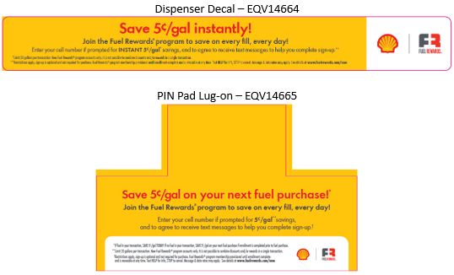
Fuel Rewards® Point of Sale Enrollment (FRE) was launched in 2018 as an easy, fast, and low touch way to grow more loyal customers at your sites! If a customer is prompted, they can instantly save 5¢/gal when they enter their mobile number and they will receive a text message to sign up for the Fuel Rewards® program. Since FRE was launched, it has been the largest channel for acquiring new active members. Please ensure all sites that have FRE enabled are displaying the required dispenser decal and PIN pad lug-on. Replacements can be ordered by calling Momentara, formerly Pointsmith, at 1-800-762-5213, sending an email to shellemailorders@pointsmith.com, or on the Beyond POP page by typing FRE or the SKU in the search box.
SKU | Item
EQV14664 | FRE Decal NCA 9.25 x 1.125
EQV14665 | FRE Pin Pad Lug

