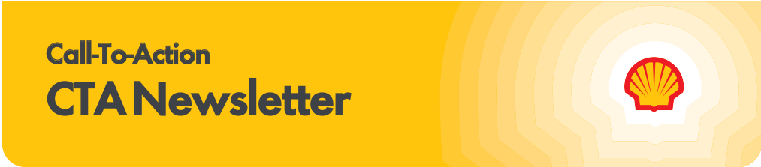

Subscribe to the CTA newsletter to receive it directly via email. Click here to find out more.
January 27, 2026
Featured Topics

In-Store Rewards – January Offers
Help drive consumer awareness and increase your c-store sales by printing the POP and displaying the In-Store Rewards products near the register. As a reminder, members with Platinum Status earn 2x on all In-Store Rewards offers.

- Power Deal - Buy 3 Tic Tac 1.7 oz packs, earn 10¢/gal
- Buy 2 Trident Singles, earn 5¢/gal
- Buy 2 100% Natural Spring Water 700 mL, earn 5¢/gal
- Buy 1 100% Natural Spring Water 25 oz, earn 5¢/gal
- Buy 1 100% Natural Spring Water case pack 24/16.9 oz, earn 5¢/gal
- Buy 1 Pure Life® case pack 24/16.9 oz, earn 5¢/gal
- Buy 2 Sparkling Ice® Caffeine, earn 5¢/gal
- Buy 1 Sparkling Ice® Starburst™, earn 2¢/gal

Click Here to view the reference materials including high resolution artwork, POP templates for local printing, flyer with UPCs, change mat inserts and Wayne Anthem dispenser slides. Check the Fuel Rewards® or Shell App regularly to view additional short-term digital only offers.
If you have any questions, please contact mark.dyer@shell.com.

Important Updates

Stop by the Shell Booth #169 at WPMA!

Shell is excited to attend WPMA 2026. Be sure to visit us at Booth #169 to see the new and improved Shell V-Power Nitro+ Performance Trailer and take part in an exclusive technology tour led by a Shell scientist. While you’re there, don’t forget to pick up your custom Shell backpack.

If you’re attending WPMA, we also invite you to join us for our Brand Meeting and hospitality events on Wednesday, February 18, where we’ll share a preview of Shell’s plans for 2026. If you have not received an invitation, please reach out to your Territory Manager.


Tips for Using Shell MarketHub
Thank you for using and engaging with Shell MarketHub 2.0. Here are some quick tips to help you navigate the website:

  - For training materials and videos, you can find the Additional Resources page under the Programs tab in the Site Readiness category.
  - To switch between Sold To Accounts, check your Active View and Product Type at the top of the homepage and click the Change button to the right.
  - To have a one on one training session, you can schedule a call with the Shell Solutions Center here.

For more tips and information, please visit the Additional Resources page for Frequently Asked Questions and training guides. You can also email ssc@shell.com for support.

New Year, New Savings on 5G Internet
Celebrate the new year with savings and better connectivity. The Shell + T-Mobile Diamond Deal gives you enterprise-grade 5G Business Internet, premium hardware, and professional installation—all starting at just $110/month*.
Sign up through our microsite and get a FREE Network Location Assessment from a T-Mobile for Business Expert. Know your coverage before you commit and unlock exclusive Shell benefits.
Start 2026 with enterprise-grade business Internet, reliability, and savings.
*Rooftop installs require upgraded hardware and an additional $30/month

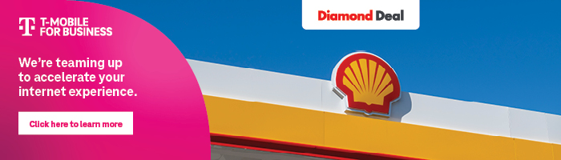

The Power of Loyalty

10-20-30 Shell® Fuel Rewards® New Member Offer – Campaign is now Live!

The 10-20-30 Shell Fuel Rewards® New Member Offer Campaign is now live! As a reminder, the offer runs through December 31, 2026, to keep customers coming back and boosting your bottom line. New Point-of-Purchase (POP) materials should be displayed at all sites and are designed to make joining easy and rewarding.

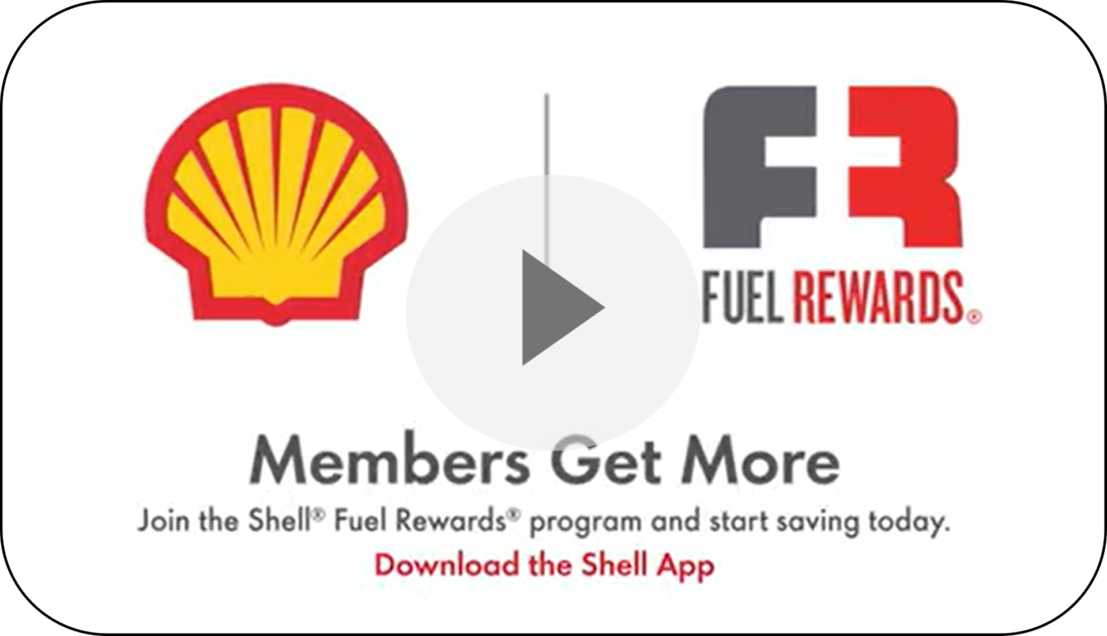
In case you missed it, click on the image to view the 10-20-30 Shell Fuel Rewards® New Member Offer commercial! This commercial is live in market and is included in the GSTV loop at sites.

As a reminder, customers simply scan the QR code on POP materials to join Shell Fuel Rewards® in the Shell App. With one-step integrated account creation, every new Shell App user becomes a Shell Fuel Rewards® member - fast, seamless, and ready for savings all year long.

More active members = more gallons + more in-store sales. Every year, the average Shell Fuel Rewards® member delivers 360 gallons + $115 in-store spend annually*.

Links to Learn More:
- Current Campaigns MarketHub Page – View POP materials and other campaign creatives
- Fuel Rewards® MarketHub Page – View more information about the upcoming campaign

*Average annual purchases by Fuel Rewards Members.

